

*Welcome to Fifth grade! I grew up in the Randolph County area near Asheboro. This is my 21st year of teaching.* My goal every year is to be there for both my students and their parents. I want to make this journey as easy as possible for everyone. I am always here to communicate with and help with any confusion. I am ready to start this year and continue with focusing on restoring the ROAR with you!

*I look forward to a wonderful year as our class mission is to* ***create a better me to make Lindley a wonderful place to be!***

**All About Mrs. Barnett MisFrancisco**

**My Hobbies**

I love making memories with my family, creating projects with my Cricut, Lego flowers and taking photos.

**Where I’ve Taught**

This is my 21st year teaching! I have taught 2nd, 3rd, and 4th grades. I have taught at Vandalia and McNair Elementary in GCS.

**My College**

I graduated college from

**East Carolina University!**

**Go Pirates!!**



I have 2 cats, Shadow & Stormy. I also have 9 goats!!



**My Family**

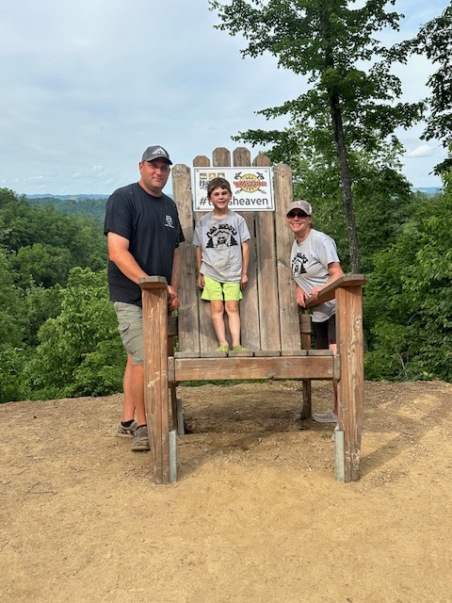

I have been married for 14 years (Sept. 4th). My husband is an Assistant Chief at Fire District #13, Inc. We have a beautiful, energetic 7-year-old. Keegan loves to paint, play cars and trucks, mow with his dad, fish, and ride SXS in the beautiful West Virginia. He will be in 2nd grade at Lindley this year!

**My Contact Info**

Misty Barnett

barnetm@gcsnc.com

336-294-7360 (school)

336-517-7725 (personal)

**My Professional Goals**

My goal this year is to focus on the word **INSPIRE**. I want to inspire all my students to be the best version of themselves that they can be. I also want to stay focused and inspire myself to become a better teacher!

**My Favorite Books**

Because of Winn Dixie,

Bud, Not Buddy, Wish

Charlotte’s Web, Ruby Holler, and Where the Red Fern Grows